The Art of Childlike Listening
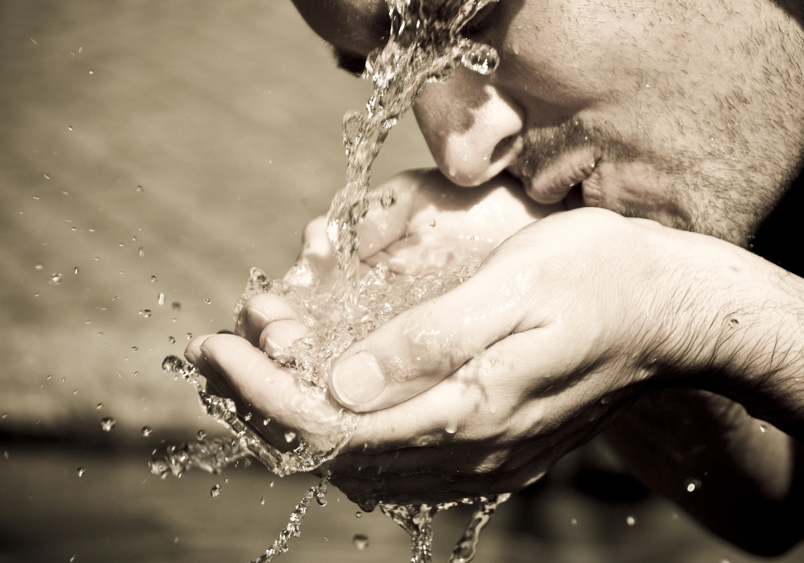

“I say to you, unless you are converted and become as little children, you will by no means enter the kingdom of heaven.” Matthew 18:3

“Your ears shall hear a word behind you, saying, "This is the way, walk in it,"
Isaiah 30:21

Journal any words or reflections you sense the Spirit prompting:

“You will show me the path of life; In Your presence is fullness of joy;
At Your right hand are pleasures forevermore.” Psalm 16:11

©Gary Schmitz – Citywide Prayer Movement KC (Permission to copy for the glory of God!)

The Invitation to Thirst
for God

“Whoever is thirsty, let him come; and whoever wishes, let him take the
free gift of the water of life.” Jesus in Revelation 22:17

I was created by God – with deep human yearnings (“thirsts”)

“Your hands have made me and fashioned me, An intricate unity” Job 10:8 NKJV
“You make him a little lower than the heavenly beings
And crowned him with glory and honor…” Psalm 8:5
“He has also set eternity in the hearts of men…” Ecclesiastes 3:11 NIV

The Bible says that in creating me a human being God has planted eternity (part of His infinite glory and majesty) deep inside my heart. This planting of eternity in my inner life causes an “ache” or yearning for something beyond what this temporal life can satisfy. (Romans 8:22, 26; 2 Cor 4:17-18) The Bible uses the metaphor of “thirst” to describe a group of human yearnings that drive life behavior and decisions (Examples of yearnings are my need to be loved, my need to experience pleasure or joy and my need to be significant). Only by directing all my “thirsts” toward God and seeking to encounter His heart, can I ever experience true joy and be satisfied in this life!

“Deep in our humanness is an ache for fullness, for infinity.” Fr. Thomas Dubay

“O God, you are my God, earnestly I seek you; my soul thirsts for you,
my body longs for you, in a dry and weary land where there is no water.”
Psalm 63:1 NIV
Finding the “Thin Places”
In the ancient Celtic tradition a “thin place” is when the veil between the elements of heaven and the elements of earth becomes so thin that we sense or encounter the very real presence of God.

“Draw near to God and He will draw near to you…” James 4:8

Take time for quiet personal worship of our Awesome God

“…when you pray, go into your room, and when you have shut your door,
pray to your Father who is in the secret place; and your Father who sees in
secret will reward you openly.” Matthew 6:6

Some Roadblocks to thirst and yearning for God:

- Do I have a sense of apathy, dullness or indifference to the things of God? Ask the Holy Spirit: “Increase my thirst!”

- Do I battle with constant distractions? List them:

- Have I allowed my life to become filled with busyness? What adjustments could make room to be with God?

- Am I overindulgent in areas of materialism, entertainment, things of the world?

- Do I have habitual sins or character flaws to confess?

Ask Jesus to cleanse your heart to prepare you for His Presence:

“Create in me a clean heart, O God,
And renew a steadfast spirit within me.”
Psalm 51:10
My heavenly Father longs to be with me!
Quietly read the following verses and write down what these words mean to you:

"Yes, I have loved you with an everlasting love;
Therefore with lovingkindness I have drawn you.” Jeremiah 31:3 NKJV

“He rescued me because he delighted in me.” King David in Psalm 18:19

“Be still and know that I am God.” Psalm 46:10

“Thirst” is a fundamental expression of the human heart in response to God’s amazing grace and tenderness:

Using the words of King David write or pray in your own words the expression of your personal thirst (yearning) for God:

“O God, you are my God, earnestly I seek you;
my soul thirsts for you, my body longs for you,
in a dry and weary land where there is no water.

I have seen you in the sanctuary
and beheld your power and your glory.
Because your love is better than life, my lips will glorify you.
I will praise you as long as I live,and in your name I will lift up my hands.
My soul will be satisfied…”
Psalm 63:1-5

